LCD Tech Team Meeting
5/12/20
Attendees: Natalie, Mary, Sean, Peggy, Adam, Ken, Phil, Aubin, Matt

Introductions and Welcome Peggy
- Natalie Poremba – Crown Managers Partnership, Coordinator
- Mary McFazden – MSU, Cooperative Agreement – science outreach and communications, but excited to help in any way possible
- Sean Finn– Science Coordinator USFWS Region 6 – PI of the LCD – CMP Steering committee member
- Peggy Holroyd– Alberta, Landscape and Rec planner, transboundary planning and cumulative effects – has been following the development of LCD project
- Adam Collingwood– Geomatic Coordinator for waterton – worked with CMP previously
- Ken Sanderson – Mistakiis, GIS guy
- Phil Matson– Database manager for CMP, Research Coordinator for Flathead Lake Bio Station
- Aubin Douglas– cartography and GIS fellow – USFWS – based in lakewood, CO – working on Lost Trail planning
- Matt Heller– works with Mary and Sean at USFWS, GIS guy also, cartographer, geospatial work, data mgmt., programming, worked in the Crown in the past (north fork of flathead) – Bozeman, MT

Project Area map (see attached map): Leadership Team Decision and debrief (Phil)
- Based boundary on watersheds at HUC10 level (See figure below)
- Pitched it to the leadership team last week, and the leadership team accepted it!
- Action: Phil will send out the GIS layer
  - We can start to use sciencebase

Feature Selection
- General process, guidelines, and criteria (Sean)
  - Our end goal is to use modeling to show us how to get from our current conditions to desired conditions - Using marxan, we will select features that are representative of the entire crown geography – the features will be diverse and can be coarse or fine (ie. Grizzly vs. carnivores) – they may also be ecological processes (ie. Ecological disturbance) – economic features – and cultural features
  - When we develop this design, it will hopefully be post-pandemic – we have an opportunity to consider what our new normal will look like – it will be important to bring in folks who are experts in sociocultural fields
  - Criteria for features:
    - Representative of ecology, social, and cultural aspects
    - Comprehensive
    - Extent/range
    - Impact/importance (ie. Mule deer have recreational importance and bio importance)
    - Context (there may be features we don’t know enough about)
    - Contentiousness – we want it to begin with non-contentious features– after we build trust and go through several phases, we can begin to approach topics that are more contentious
    - Data available
    - data quality
      - Will it be collected into the future? Is it sporadic?
  - Comprehensive review of various plans
    - We are scanning through about 50 agency plans throughout the Crown to determine 1. What partners are thinking about in terms of priorities, and 2. what is our collective expertise.
      - So far, grizzly, bull trout, elk, and wolverine are important species
      - We are also looking at when plans mention ecological processes (ie. disturbance), habitats (ie. riparian), social factors (ie. education and cultural resources) or economics (ie. Timber harvest)
      - This review allows us to start by surveying what’s out there and then create a strategy on how to focus in
    - Action: Tech team, If there are additional documents/plans that should be reviewed, please bring them forth
  - How do we treat landscape features?
    - Our end goal: Create a spatial model that shows where we have conservation opportunity with limited cost
    - Steps to get there:
    - 1. Understand landscape features (conceptual models – they already exist for many features, and we will not reinvent the wheel, but draw from them)
    - 2. Key attributes and indicators; spatial context - what data is needed?
    - 3. Measurable objectives – characterize the desired future conditions
      - It’s possible that the measurable objectives are not rooted in existing scientific papers (for example, we may not know from scientific literature how many cubs birthed in a year constitutes “very good”) – however, if we are selecting features valued by most everyone on the landscape, it is likely that there will be published science
    - 4. Barriers to objectives aka Cost
    - 5. Spatial models
      - It’s possible that features may not have data across all jurisdictions – in Marxan, you can run models where areas are subdivided – we may consider doing this if the data demands it
    - The “baton” will be passed from leadership team to tech team to subject matter experts to analysis team as the process unfolds
  - Note: This is an iterative process and there is space for adjustment!
- Management Plan Review: insights so far (Natalie)
  - Some members of the leadership team expressed that they felt overwhelmed looking at the features sheet - Is there a systematic way that we can organize features that might make it easier for the leadership team to digest?
    - We would want to create a system in which we don’t unintentionally cull out species that may be important when considered in conjunction with another – for example, limber pine only has 4 counts, but when combined with the similar whitebark pine (6 counts), it has one of the highest count totals.
  - Combine into larger groups
    - Carnivores, migrating ungulates, Cool water fish, Use broader categories
      - If we use broad categories, we could use different representative species in different jurisdictions
  - Show the leadership team only the highlights
    - Species only identified once or twice may not have as much data
    - If we pitch a species list and something is missing, people will be vocal
  - For next steps, Sean and Natalie will come up with a basic structure/draft strategy for categorizing/organizing

Recruitment of subject matter expert teams
- We need to start using our network to identify folks who have expertise in sociocultural and economic features - Many of us are bio focused
  - Peggy’s project example of TEK metrics created by Treaty 6 Nation
    - It is hard to engage if funding is not available
  - Recreation – availability of opportunities and diversity of opportunities
  - Action: Tech team, reach out to colleagues who may be experts in social science areas
- As we narrow down landscape features, we will want to connect with specific experts (ie. Grizzly experts, riparian experts ) and create ad hoc teams to dive deep
  - Expert participation helps us be more efficient – we won’t have to continually sift through literature
  - Time Commitment: 5-6 hrs between now and sept (1hr monthly phone call)
  - Some features that seem like they will be selected: cold water salmonids, ungulates
  - Action: Tech Team, Start thinking about experts in your agency on these topics that could participate in ad hoc expert calls

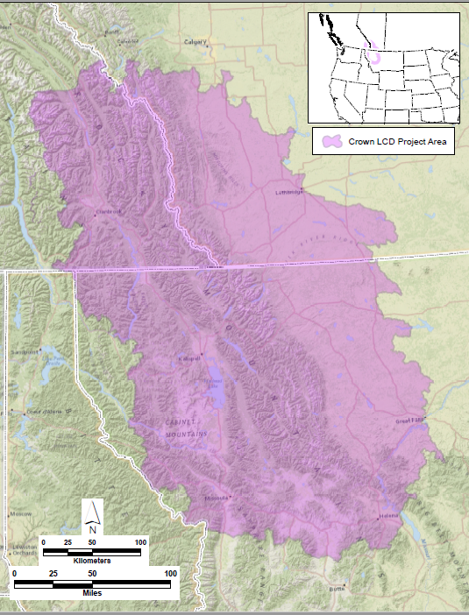
Our Project Boundary!

